
American International University-Bangladesh (AIUB)
Faculty of Engineering
Department of CSE, EEE, and CoE
EEE4103 MICROPROCESSOR AND EMBEDDED SYSTEM
COURSE CAPSTONE PROJECT PROPOSAL FORM

SEMESTER: Fall 2025-26
PROJECT TITLE: Smart Crop Recommendation System for Bangladesh Using IoT Sensors and Cloud Machine Learning.
SURVEY: (to develop a process for complex engineering problems considering cultural and societal factors (use Google or Microsoft Forms to design questions, show the outcomes in the form of a pie/bar chart, show the links of questions, minimum 10 questions, and 40 respondents), present survey link 7 MARKS
AIMS AND OBJECTIVES OF THE PROJECT: (there must be a minimum of three aims and objectives of your work using measurable action verbs of Bloom’s Taxonomy, for example, design, simulate, implement, analyze, etc.) 4 MARKS
LITERATURE REVIEW: (must be related to embedded system design with other necessary citations from the most recently published papers. At least 5 most recent publications must be collected, studied, identified the problems, and then discussed in this section) 5 MARKS
EXPERIMENTAL BLOCK DIAGRAM: (demonstrate how this project is interconnected with various components and how various signals flow among them using text boxes and arrows) 5 MARKS
POSSIBLE OUTCOMES OF THE PROJECT: (describe how this project can help society and improve the culture of society) 4 MARKS
PROJECT TIMELINE (GANTT CHART): describe how this project will progress with time by breaking the whole task into several components concerning some specific time using a horizontal or vertical bar graph) 5 MARKS
REFERENCES: (only published paper-based references are allowed with the IEEE format, don’t use YouTube links, Wikipedia, or any random websites for references; however, datasheets, databases, can be used as references with the appropriate formats, links, and access dates): 3 MARKS
Sample for the conference paper:
[1] M. H. Bhuyan and Q. D. M. Khosru, “Linear Asymmetric Pocket Profile Based Pinch Off Voltage Model for Nano Scale n-MOSFET,” Proceedings of the IEEE sponsored International Conference on Electrical, Computer and Communication Engineering (ICECCE2017), organized by the Chittagong University of Engineering and Technology (CUET), Cox’s Bazar, Bangladesh, 16-18 February 2017, pp. 28-32.
Sample for the journal paper:
[1] M. H. Bhuyan and Q. D. M. Khosru, “Effects of Temperature on Reverse Short Channel Effect in Pocket Implanted Sub-100 nm n-MOSFET,” Journal of Materials Science and Engineering, USA, 1934-8959, vol. 4, no 7, July 2010, pp. 18-23, DOI:10.17265/2161-6213/2010.07.004.

Instructions:
- There is no definite format for writing the course project proposal, but students must follow the instructions mentioned above properly.
- Fill in the form accurately with all necessary information.
- Make a color print on this form.
- Figures, tables, charts, circuit diagrams, block diagrams, and wave shapes must be color printed.
- The survey form links with the answers that must be provided in the proposal form.

FOR FACULTY USE ONLY
COMMENTS BY COURSE TEACHER:

COURSE TEACHER’S NAME COURSE TEACHER’S SIGNATURE DATE

GROUP MEMBERS
(Maximum 7 students are permitted to carry out a single Project. However, depending on the capability of the students, 4 students may be allowed, but not fewer than that.

NAME: M. O. B. JIHAD  ID : 21-44811-1  PROGRAM: CSE  EMAIL: |  |  | NAME: JONAYED AL MOSTAFA  ID : 22-47246-1  PROGRAM: EEE  EMAIL:
NAME: IFTEKHAR BIN SHOIB  ID : 23-52337-2  PROGRAM: CSE  EMAIL: |  |  | NAME: MD. RAKIBUL HASSAN  ID : 23-52453-2  PROGRAM: CSE  EMAIL:
NAME: MD.MAMUN UR RASHID  ID : 22-46230-1  PROGRAM: CSE  EMAIL: |  |  | NAME: ZINEDINE ZIDANE KHAN  ID : 23-53225-3  PROGRAM: CSE  EMAIL:
NAME: MD. RIFAT AHMED KHAN
ID : 23-51796-2
PROGRAM: CSE
EMAIL:
REMARKS (for OFFICE use only)

Course Name: |  | Microprocessor and Embedded System |  | Course Code: | EEE 4103
Semester: |  | Fall 2025-26 |  | Sec:
Faculty Member:
Capstone Project Title:
Project Group No.08
Sl # | Student ID # | Student Name |  | Obtained Marks
1. | 21-44811-1 | M. O. B. JIHAD
2. | 22-47246-1 | JONAYED AL MOSTAFA
3. | 23-52337-2 | IFTEKHAR BIN SHOIB
4. | 22-46230-1 | MD.MAMUN UR RASHID
5. | 23-52453-2 | MD. RAKIBUL HASSAN
6. | 23-53225-3 | ZINEDINE ZIDANE KHAN
7. | 23-51796-2 | MD. RIFAT AHMED KHAN

Assessment Materials and Marks Allocation:
COs | Assessment Materials | POIs | Marks
CO3 | Course Capstone Proposal Form | P.c.2.C6 | 35

Assessment Rubrics:
KPIs | Excellent  [2] | Proficient  [1.5] | Good  [1] | Acceptable  [0.5] | Unacceptable  [0] | No Response  [0] | Secured Marks
Project Title | The title reflects an issue related to complex engineering problems, showing targets and methods with possible outcomes. | The title reflects an issue related to complex engineering problems, showing targets and methods, but some missing issues. | The title reflects an issue related to the course capstone project, but there may be some missing issues. | The title reflects an issue related to the course capstone project, but it is not complete or specific. | The title does not reflect any issues related to the course capstone project. | No Response at all/ copied from others /identical submissions with gross errors/ image file printed
Comments |  |  |  |  |  | Total Marks (2)

KPIs | Excellent  [6-7] | Proficient  [4-5] | Good  [3] | Acceptable  [2] | Unacceptable  [1] | No Response  [0] | Secured Marks
Survey | The survey developed as a process for complex engineering problems, considering cultural and societal factors, has superior variables, targets, measures, and  the implementation process is clear and challenging for future project implementation, with several possible outcomes having good impacts. | The survey, developed as a process for complex engineering problems, considering cultural and societal factors, has good variables, targets, measures, and  The implementation process is clear and challenging for future project implementation, with some possible outcomes and little impact. | The survey developed as a process for complex engineering problems, considering cultural and societal factors, has moderate variables, targets, measures, and  The implementation process is clear and challenging for future project implementation, with a few possible outcomes and impacts. | The survey, developed as a process for complex engineering problems, considering cultural and societal factors, has good variables, targets, measures, and  The implementation process is somewhat clear for future project implementation, with very few possible outcomes and little impact. | The survey developed as a process for complex engineering problems, considering cultural and societal factors, has poor variables, targets, measures, and  the implementation process is very unclear for future project implementation, with a few possible outcomes but no impacts. | No Response at all/ copied from others /identical submissions with gross errors/ image file printed
Comments |  |  |  |  |  | Total Marks (7)
KPIs | Excellent  [4] | Proficient  [3] | Good  [2] | Acceptable  [1] | Unacceptable  [0.5] | No Response  [0] | Secured Marks
Aims and Objectives | Aims and objectives are written to solve complex engineering problems, considering cultural and societal factors with specific targets, measurements, and implementation processes that are clear and challenging, and have several possible outcomes having very good impacts. | Aims and objectives are written to solve complex engineering problems, considering cultural and societal factors with general targets, measurement, and implementation processes that are not clear and challenging, and have some possible outcomes that have a good impact. | Aims and objectives are written to solve complex engineering problems considering a few cultural and societal factors with narrow targets; measurement, and implementation processes are clear and challenging and have a few possible outcomes, having some impacts. | Aims and objectives are written to solve complex engineering problems considering cultural or societal factors with a very specific target; measurement and implementation processes are not clear or challenging, and have little possible outcome, having no impact. | Aims and objectives are written to solve complex engineering problems, but do not consider cultural and societal factors with any targets; measurement and implementation processes are not clear and challenging, and no possible outcomes that have an impact. | No Response at all/ copied from others /identical submissions with gross errors/ image file printed
Comments |  |  |  |  |  | Total Marks (4)

KPIs | Excellent  [5] | Proficient  [4] | Good  [3] | Acceptable  [2] | Unacceptable  [1] | No Response  [0] | Secured Marks
Literature Review | Specific formats are maintained to review and cite the literature with recent publications. Identified and analyzed the problem correctly. | Specific formats are maintained to review and cite the literature with recent publications. Identified and analyzed the problem correctly, but not all issues were addressed with relevant or intended work. | Specific formats are maintained to review and cite the literature with recent and past publications. Identified and analyzed the problem correctly, but not all issues were addressed with relevant or intended work. | Specific formats are maintained to review and cite the literature with recent and past publications. Identified but could not analyze all the problems correctly, and all issues were not addressed with relevant or intended work. | No specific formats are maintained to review and cite the literature with recent publications. Could not identify and analyze all the problems correctly, and all issues are not addressed with relevant or intended work at all. | No Response at all/ copied from others/ identical submissions with gross errors/ image file printed
Comments |  |  |  |  |  | Total Marks (5)

KPIs | Excellent  [5] | Proficient  [4] | Good  [3] | Acceptable  [2] | Unacceptable  [1] | No Response  [0] | Secured Marks
Experimental Block Diagram | The block diagram is drawn to show the connections of all the possible components or subsystems to show their interdependence with all possible flows of signals from inputs to outputs. | The block diagram is drawn to show the connections of all of the possible components or sub-systems to show their interdependence, with a few missing flows of signals from inputs to outputs. | The block diagram is drawn to show the connections of most of the possible components or sub-systems to show their interdependence, with a few missing flows of signals from inputs to outputs. | The block diagram is drawn to show the connections of a few possible components or sub-systems to show their interdependence, with some missing flow of signals from inputs to outputs. | The block diagram is not drawn to show the connections of all possible components or sub-systems, to show their interdependence and flow of signals from inputs to outputs. | No Response at all/ copied from others /identical submissions with gross errors/ image file printed
Comments |  |  |  |  |  | Total Marks (5)

KPIs | Excellent  [4] | Proficient  [3] | Good  [2] | Acceptable  [1] | Unacceptable  [0.5] | No Response  [0] | Secured Marks
Possible Outcomes | Outcomes are written to achieve complex engineering problems’ solutions, considering cultural and societal factors and showing measurement and implementation processes to attain the outcomes with all possible impacts. | Outcomes are written to achieve complex engineering problems’ solutions, considering cultural and societal factors and showing measurement and implementation processes to attain the outcomes with some impacts. | Outcomes are written to achieve complex engineering problems’ solutions, considering cultural and societal factors, and do not show measurement and implementation processes to attain the outcomes without showing any impacts. | Outcomes are written to achieve complex engineering problems’ solutions, but do not consider cultural and societal factors, and do not show measurement and implementation processes to attain the outcomes without showing any impacts. | Outcomes are not written to achieve complex engineering problems’ solutions, do not consider cultural and societal factors, and do not show measurement and implementation processes to attain the outcomes without showing any impacts. | No Response at all/ copied from others /identical submissions with gross errors/ image file printed
Comments |  |  |  |  |  | Total Marks (4)

KPIs | Excellent  [5] | Proficient  [4] | Good  [3] | Acceptable  [2] | Unacceptable  [1] | No Response  [0] | Secured Marks
Gantt Chart | Specific formats are maintained to draw the Gantt chart, and there is an order of workflow with all work to be done. | Specific formats are maintained to draw the Gantt chart, and there is an order of workflow with a few tasks missing. | Specific formats are maintained to draw the Gantt chart, and there is an order of workflow with some work missing. | No specific formats are maintained to draw the Gantt chart, and there is little order to the workflow, with some work missing. | No specific formats are maintained to draw the Gantt chart, and there is no order of workflow, with the most important tasks missing. | No Response at all/ copied from others/ identical submissions with gross errors/ image file printed
Comments |  |  |  |  |  | Total Marks (5)

KPIs | Excellent  [3] | Proficient  [2.5] | Good  [2] | Acceptable  [1] | Unacceptable  [0.5] | No Response  [0] | Secured Marks
References | Specific formats are maintained to write references, and all are recently published journal and conference papers having no missing information. | Specific formats are maintained to write the references, and all are journal and conference papers, but some old papers have missing information. | No specific formats are maintained to write the references, and many are internet sources with several missing information and very old references. | No specific formats are maintained to write the references, and most of them are internet sources with missing information. | No specific formats are maintained to write the references, and all are internet sources with missing information. | No Response at all/ copied from others /identical submissions with gross errors/ image file printed
Comments |  |  |  |  |  | Total Marks (3)

Project Title:
Smart Crop Recommendation System for Bangladesh Using IoT Sensors and Cloud Based Machine Learning

Survey:
This survey, conducted among 40 respondents, reveals that most farmers primarily grow rice and frequently encounter challenges in selecting the appropriate crops for their soil. A significant portion of them do not measure soil conditions before planting and rely heavily on personal experience or advice from other farmers. Weather changes consistently influence crop choices, and many respondents have experienced crop losses due to unsuitable soil or weather. There's a strong interest in technology, with a majority having smartphone access and expressing willingness to use a mobile app for crop suggestions and alerts. Furthermore, almost all respondents would find a device that recommends the best fertilizer and crops for their fields to be very helpful. SURVEY LINK : https://forms.gle/1NmZR2LucJTuPSKg6
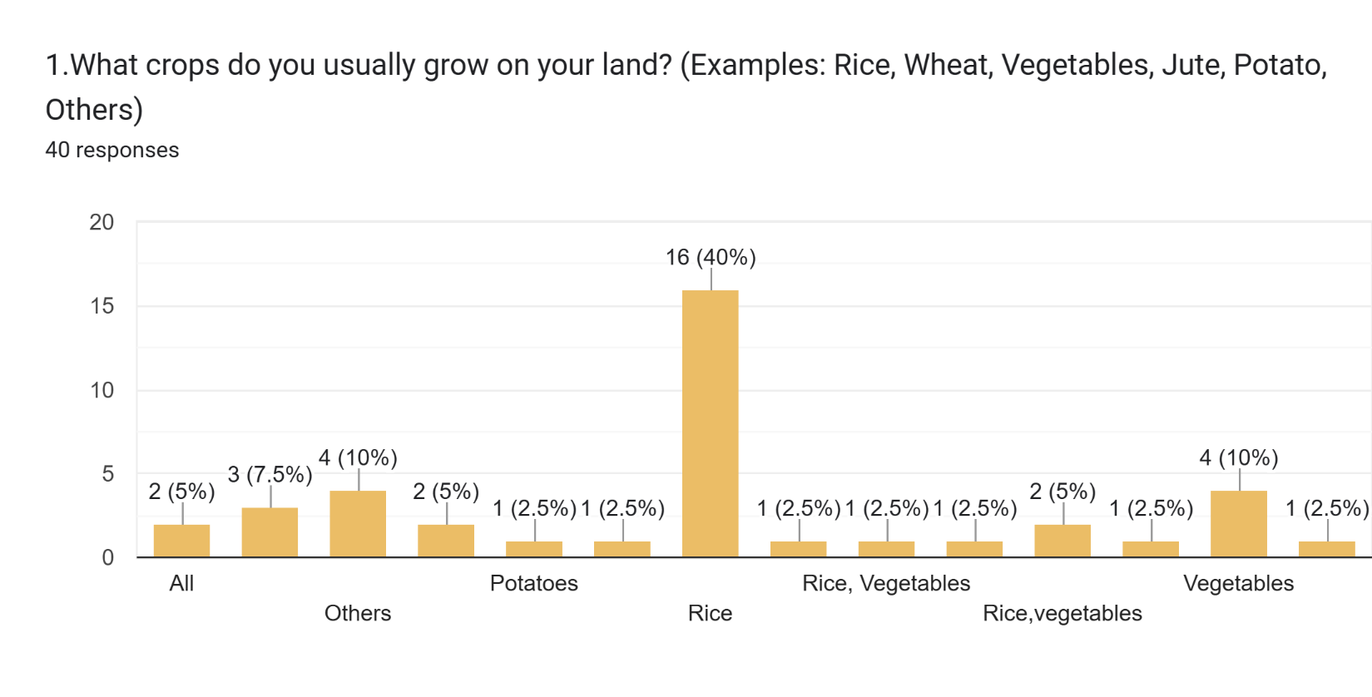
Rice is the most frequently grown crop, followed by 'Others', Vegetables, Jute, and Potato, with various other combinations also mentioned by respondents.
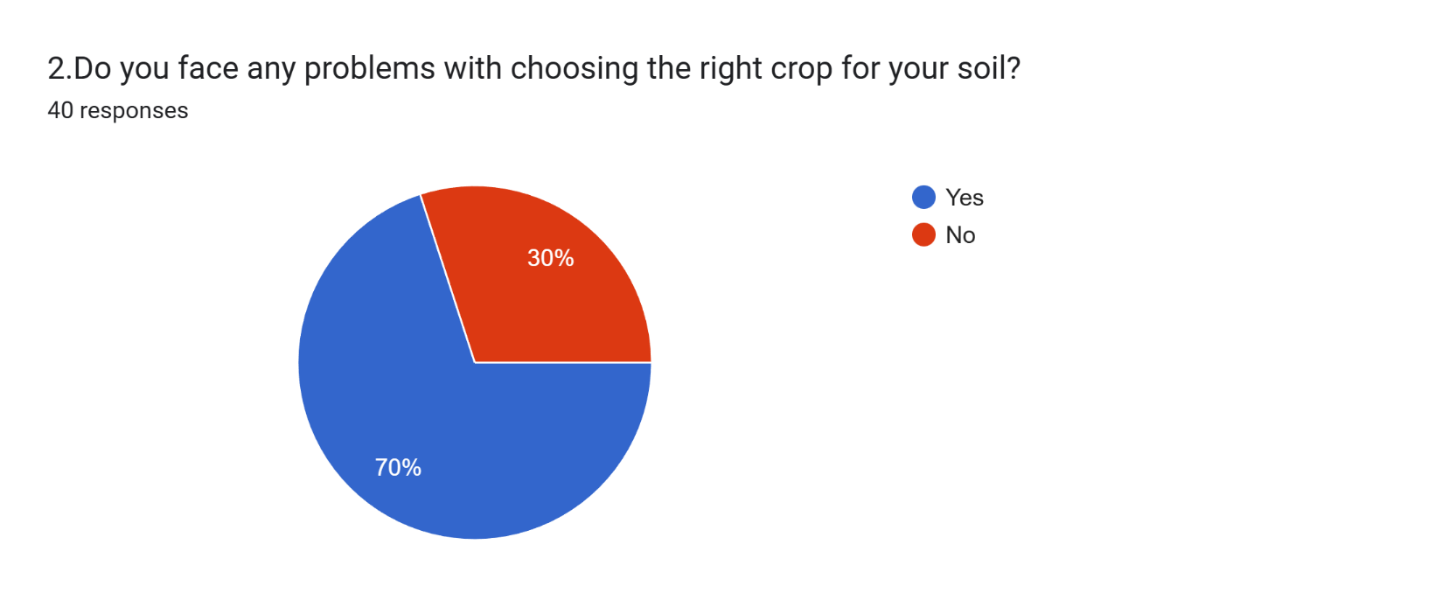
A significant majority of respondents (28 out of 40) indicated that they do experience problems when selecting the appropriate crop for their soil.
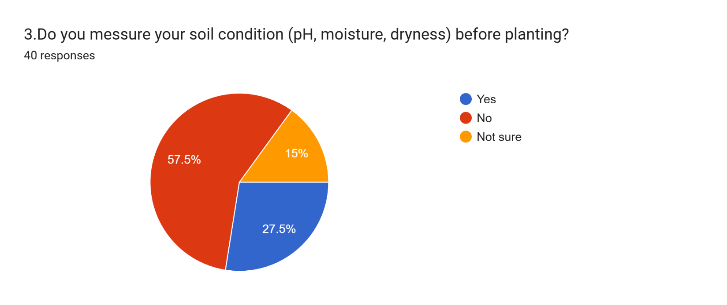
Most respondents (23 out of 40) do not measure their soil conditions before planting, while 11 do, and 6 are unsure.

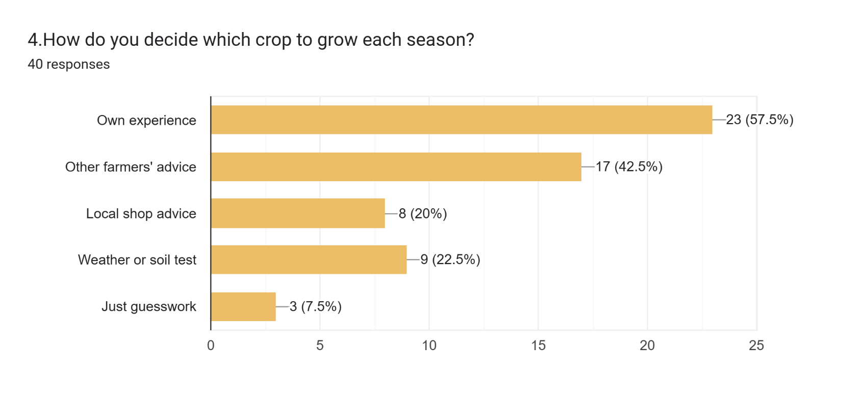
'Own experience' is the primary factor in crop selection, followed by 'Other farmers' advice', with a notable number also considering a combination of these and 'Weather or soil test' or 'Local shop advice' and 'Just guesswork’
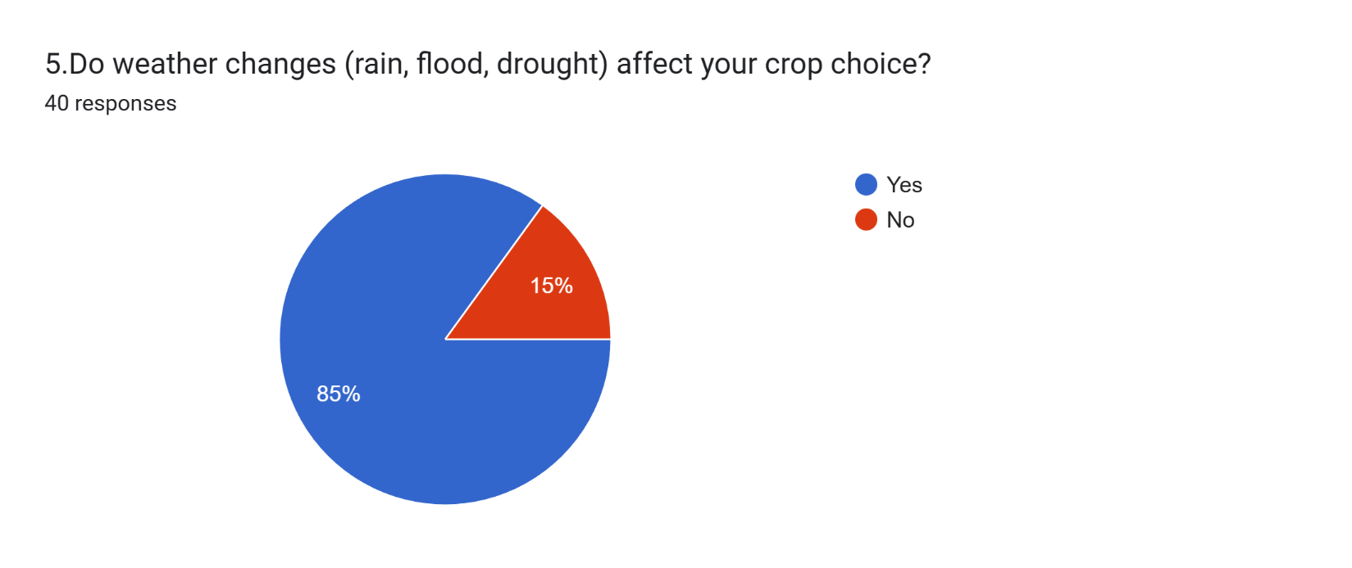
A strong majority (34 out of 40) confirmed that weather changes significantly influence their crop choices.

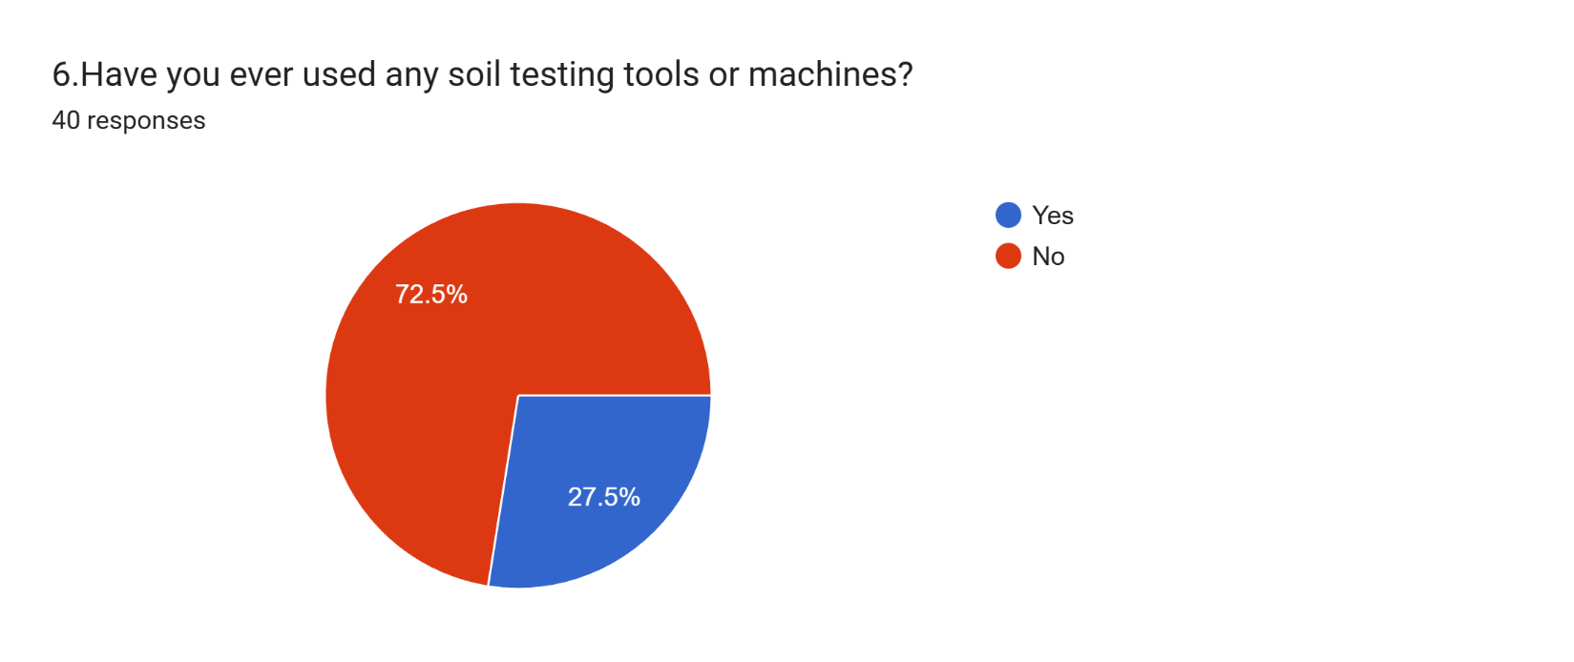
Most respondents (29 out of 40) have not utilized soil testing tools or machines, while 11 have.
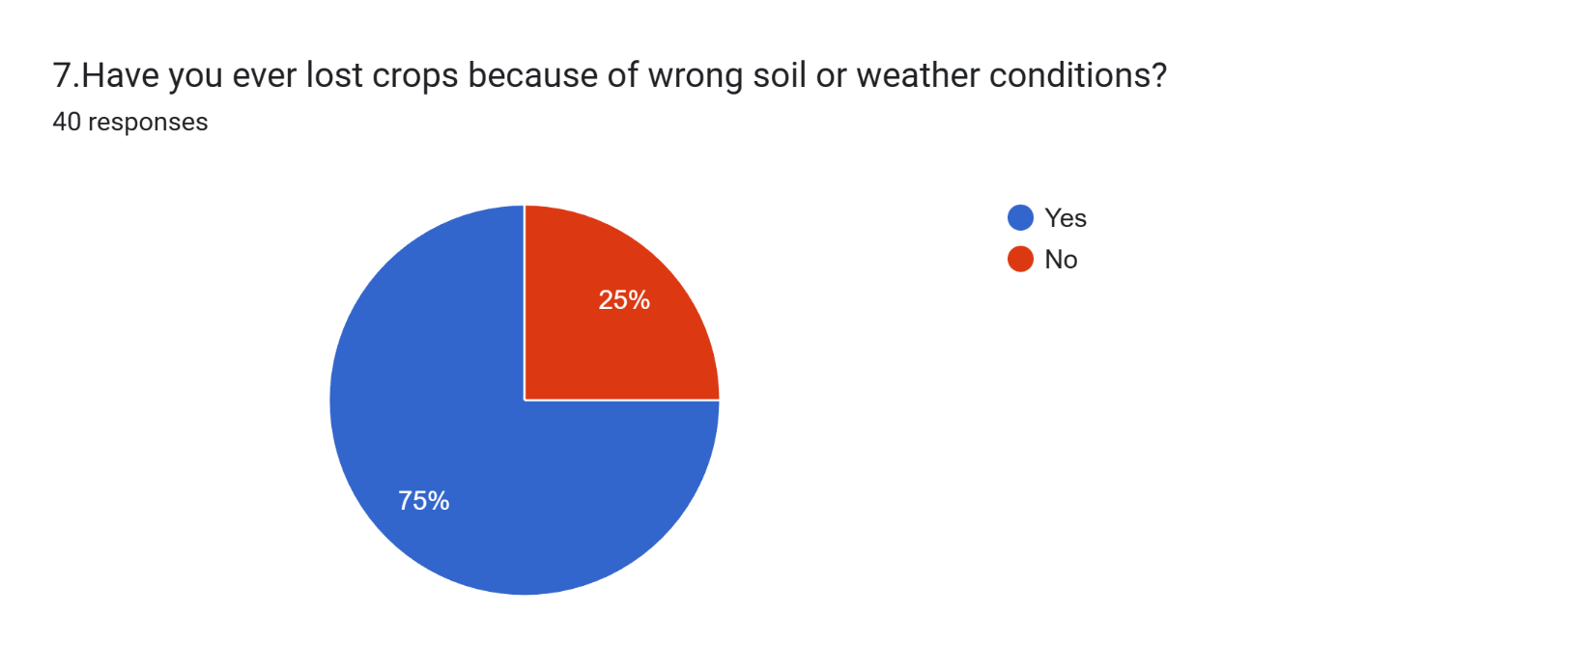
A substantial number of respondents (30 out of 40) have experienced crop losses due to unsuitable soil or weather conditions.

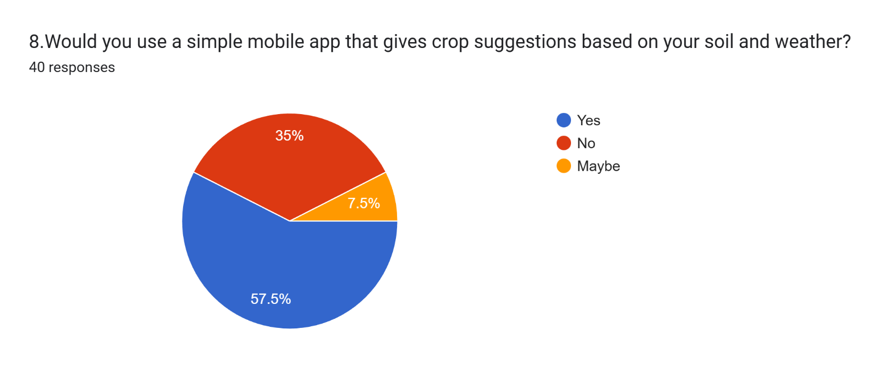
A majority (23 out of 40) would be willing to use a mobile app for crop suggestions, while 14 would not, and 3 are undecided.
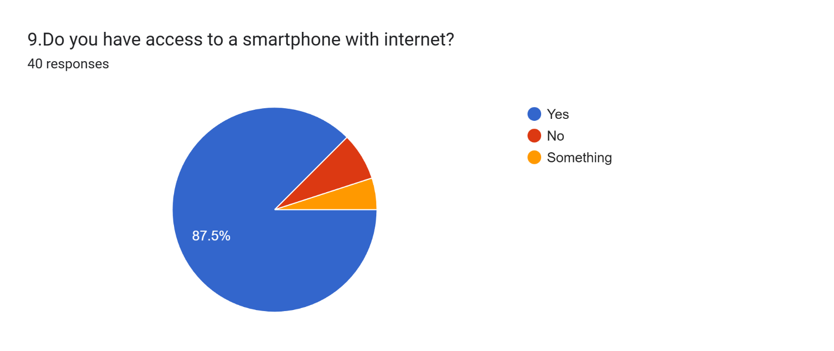
Most respondents (35 out of 40) possess a smartphone with internet access, with a few exceptions.

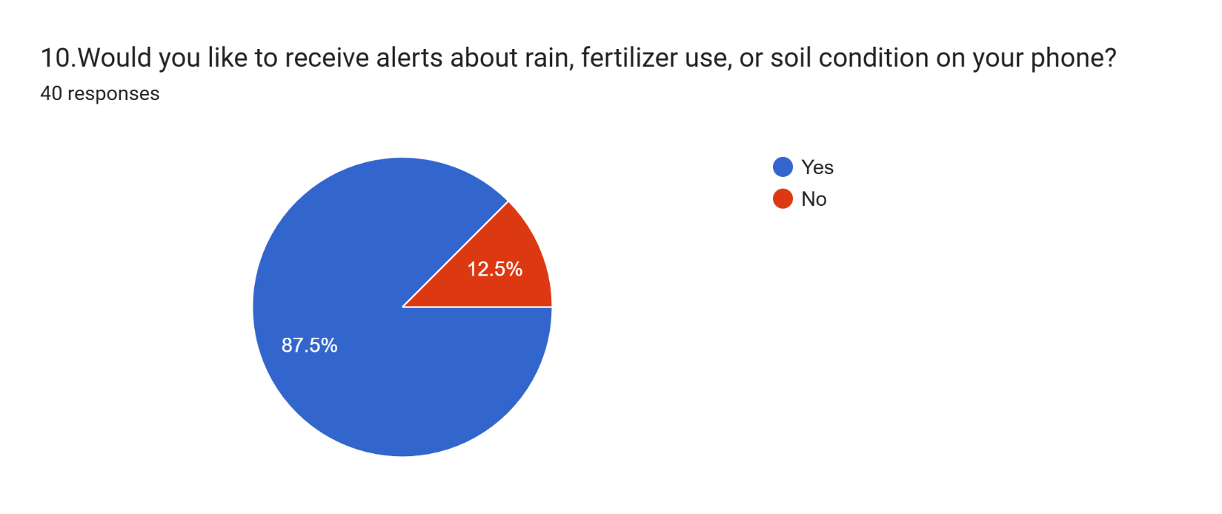
A large majority (35 out of 40) expressed interest in receiving phone alerts regarding rain, fertilizer use, or soil conditions.

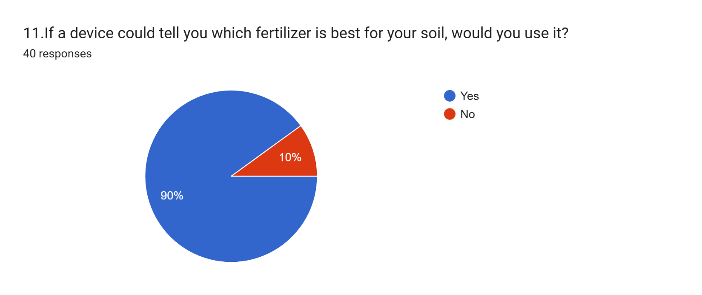
An overwhelming majority (36 out of 40) would use a device that could recommend the best fertilizer for their soil.

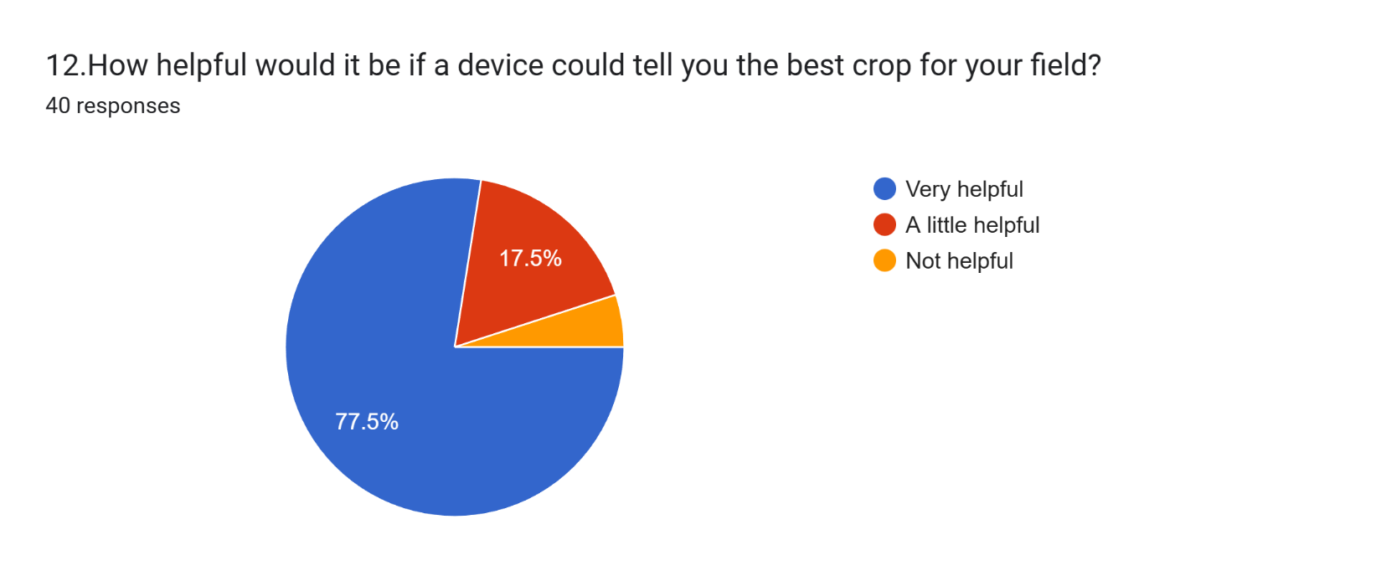
Most respondents (31 out of 40) consider a device that suggests the best crop for their field to be 'Very helpful', with some finding it 'A little helpful' and a few deeming it 'Not helpful'.

Aims and Objectives of the Project:
To design and implement a cost-effective, robust precision agriculture system tailored to the socio-economic and climatic context of Bangladesh. The system utilizes distributed IoT sensor nodes and cloud-based machine learning algorithms to optimize crop selection and enhance soil sustainability for small-scale farmers, directly contributing to national food security (SDG 2: Zero Hunger) and sustainable agricultural practices.

Objectives
- Develop a Low-Cost Sensor Node: Design and calibrate a low-power IoT sensor array capable of measuring soil pH, moisture, and NPK values with a target data accuracy variance of less than ±5%.
  - Social/Economic: Ensures technological affordability for marginal farmers, reducing barriers to entry and supporting poverty alleviation (SDG 1: No Poverty).
- Engineer a Robust Data Pipeline: Establish a resilient cloud architecture that handles data transmission from remote rural areas, implementing edge-caching mechanisms to maintain functionality during intermittent internet connectivity.
  - Governance/Infrastructure: Addresses critical rural infrastructure gaps to foster resilient agricultural innovation (SDG 9: Industry, Innovation, and Infrastructure).
- Train a Context-Aware ML Model: Develop and fine-tune a machine learning model using regional soil and weather datasets to predict crop suitability with a validation accuracy of at least 85%, specifically calibrated for Bangladeshi seasonal variations.
  - Environmental: Adaptation to local climate patterns helps farmers build resilience against climate change and unpredictable weather (SDG 13: Climate Action).
- Optimize Resource Recommendations: Formulate an algorithm to generate precise fertilizer dosage recommendations intended to reduce chemical waste by 15% while maintaining optimal soil health standards.
  - Environmental: Minimizes chemical runoff and soil degradation, promoting responsible consumption of agricultural inputs (SDG 12: Responsible Consumption & Production).

Literature Review:

Recent advancements in embedded system design have enabled smart agriculture solutions that leverage IoT sensors and machine learning (ML) to deliver precise, context-aware recommendations. To ensure the reliability and publishability of the proposed system for Bangladesh, this review analyzes state-of-the-art research, highlighting methodologies, limitations, and the specific engineering gaps this project intends to solve.
IoT Integration and Machine Learning Accuracy: The integration of microcontrollers with cloud-based ML is a dominant trend in modern agriculture. Amin et al. (2025) developed a crop recommendation system using ESP32 microcontrollers, achieving prediction accuracies of up to 96% [1]. However, their study revealed significant challenges regarding sensor drift and network unreliability, necessitating robust calibration mechanisms. Enhancing this approach, Rahman et al. (2023) introduced multi-modal data fusion, combining local sensor data with weather and satellite imagery [2]. While this improved predictive accuracy by 9-13%, it highlighted a critical trade-off: the increased computational load demands resource-efficient deployment (TinyML) to function effectively on edge devices.
Security and Infrastructure Constraints: Security in agricultural IoT is often overlooked but critical. Akter et al. (2025) proposed a "Secured Triad" architecture utilizing blockchain to ensure data integrity from sensor to cloud [3]. Although this significantly improved security, it introduced latency and complexity. The proposed project will address this by opting for encrypted API authentication, which offers security without the overhead of blockchain. Furthermore, regarding infrastructure in Bangladesh, Islam et al. (2023) validated the use of Firebase and mobile analytics in local field deployments [4]. Their work identified energy management (solar reliability) as a primary failure point, a problem this project addresses through deep-sleep modes and energy-efficient hardware selection.
The Necessity of Localized Datasets: A recurring failure in agricultural ML is the reliance on international datasets that do not reflect local soil or crop varieties. Sarker et al. (2025) curated "BanglaVeg," a dataset captured via field-embedded cameras in Bangladesh [5]. Their findings confirmed that models trained on context-specific data significantly outperform those trained on global datasets. Consequently, this project prioritizes the aggregation of regional soil and crop data to ensure high-fidelity recommendations.
Synthesis and Problem Statement: The analysis of the cited literature identifies a gap in existing solutions: while individual studies address accuracy, security, or energy independently, few systems integrate all three for the Bangladeshi context. Existing solutions often suffer from:
- Network dependency without edge/offline fallback.
- Generic datasets leading to lower real-world accuracy.
- High power consumption unsuited for rural deployment.

This project aims to bridge these gaps by engineering a system that combines multi-modal data fusion with edge-caching for offline resilience, secured via lightweight encryption, and trained specifically on Bangladesh-relevant datasets.
Experimental Block Diagram:
- Input (Sensors): Captures real-time data using Soil pH, EC/Salinity, Capacitive Moisture, DHT22 (Temp/Hum), and Rain sensors.
- Edge Processing (ESP32): The central microcontroller reads sensor signals, handles WiFi communication, and drives the local display.
- Cloud Architecture: Firebase acts as the central database, exchanging data with an ML API (Hugging Face/Gallardo) to generate crop and fertilizer predictions.
- Output Interfaces:
  - Mobile/Web App: Displays recommendations and alerts remotely.
  - Local LCD: Shows live readings and suggestions on-site via I2C/SPI.
SIGNAL/DATA FLOW
- Sensors → (Analog/Digital Signal) → ESP32 Microcontroller
- ESP32 → (Pre-processed Data via WiFi) → Cloud Database
- Cloud Database → (Input Features) → ML API
- ML API → (Predictions) → Cloud Database → Mobile App

Cloud Database → (ML Output) → ESP32 → (I2C/SPI) → LCD Display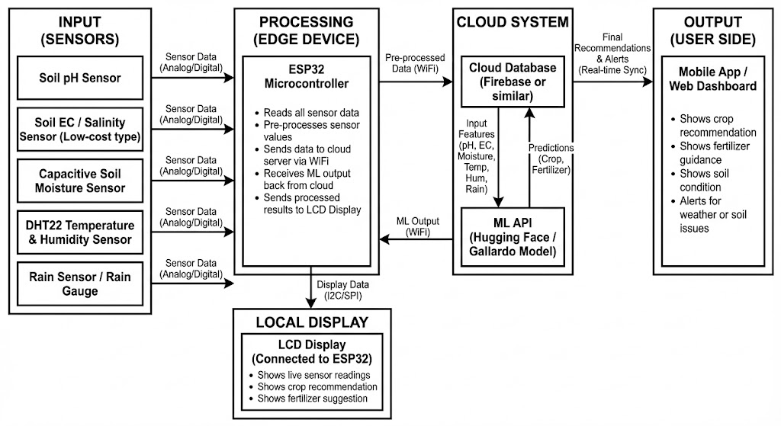
Figure 1: Experimental Block Diagram

Possible Outcomes of The Project:
- Increased crop yields and food security by giving farmers scientific, real-time crop and fertilizer advice tailored to local conditions.
- Empowerment of rural communities through easy-to-use digital tools, promoting digital literacy and inclusion.
- Environmental protection by reducing excessive use of fertilizer and water, and offering early pest/disease warnings for smarter, safer farming.
- Support for data-driven decisions by creating valuable data resources for policymakers and researchers.
- Economic growth and social well-being as farm profits rise and rural societies embrace modern, sustainable practices.
- Cultural shift toward smart, sustainable agriculture through technology adoption and farmer collaboration.

Project Timeline (Gantt Chart):

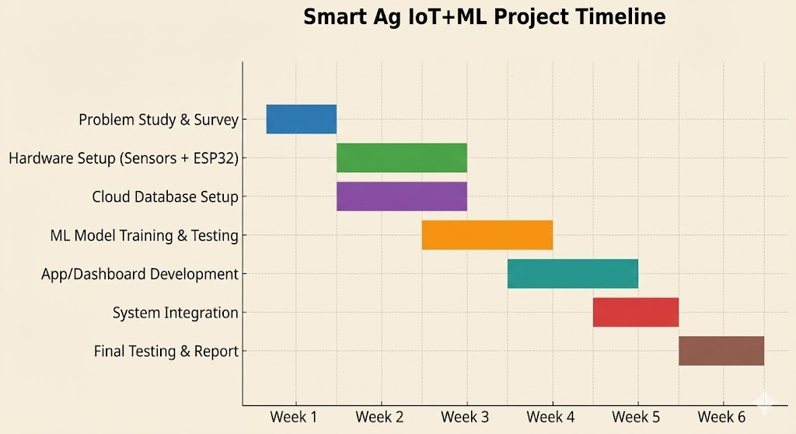
Figure 2: Project Gantt Chart

References:

[1] S. Amin, N. Rahman, and A. Hasan, “IoT-based crop recommendation system using machine learning,” Int. J. Ind. Electron. Electr. Eng. (IJIEEB), vol. 17, no. 4, pp. 52–59, Aug. 2025. [Online]. Available: https://www.mecs-press.org/ijieeb/ijieeb-v17-n4/IJIEEB-V17-N4-5.pdf

[2] M. R. Rahman, S. Mahmud, and R. Islam, “Multi-modal data fusion and deep ensemble learning for crop prediction,” [Journal Name Required], vol. 259, pp. 1–12, 2023.

[3] N. S. Sizan, A. Layek, and K. F. Hasan, “A secured triad of IoT, machine learning, and blockchain for crop forecasting in agriculture,” arXiv preprint arXiv:2505.01196, May 2025.

[4] M. Islam, S. Alam, and R. Bhuiyan, “Smart crop cultivation system using automated agriculture monitoring environment in the context of Bangladesh agriculture,” Sensors, vol. 23, no. 20, p. 8472, Sep. 2023. [Online]. Available: https://www.mdpi.com/1424-8220/23/20/8472/pdf

[5] J. Ahmed, R. Saha, A. K. Dutta, M. U. Mojumdar, and N. R. Chakraborty, “BanglaVeg: A curated vegetable image dataset from Bangladesh for precision agriculture,” Data in Brief, vol. 59, Art. no. 111441, Feb. 2025, doi: 10.1016/j.dib.2025.111441.

[6] M. R. A. Rashid et al., “Comprehensive dataset of annotated rice panicle image from Bangladesh,” Data in Brief, vol. 54, Art. no. 109682, Oct. 2023, doi: 10.1016/j.dib.2023.109682.
[7] D. P. Hughes and M. Salathé, “PlantVillage dataset,” GitHub repository, 2015. [Online]. Available: https://github.com/spMohanty/PlantVillage-Dataset

